**//Task 1:**

<!DOCTYPE html>

<html lang="en">

<head>

    <meta charset="UTF-8">

    <meta name="viewport" content="width=device-width, initial-scale=1.0">

    <title>Document</title>

</head>

<body>

    <script>

        alert("Hello World!");

    </script>

</body>

</html>

**OUTPUT:**

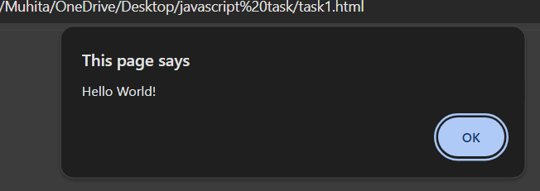

**//task2:**

let name = "Muhita";

console.log("String Example:");

console.log("Name:", name);

console.log("Type of name:", typeof name);

let age = 25;

console.log("\nNumber Example:");

console.log("Age:", age);

console.log("Type of age:", typeof age);

let isStudent = true;

console.log("\nBoolean Example:");

console.log("Is Student:", isStudent);

console.log("Type of isStudent:", typeof isStudent);

**OUTPUT**

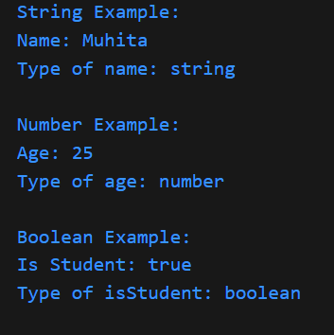

**//Task3**

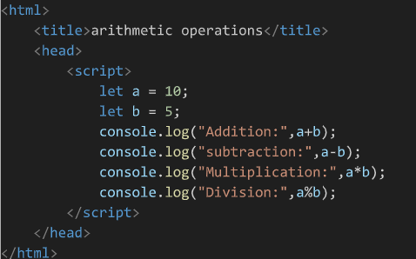

**Output**

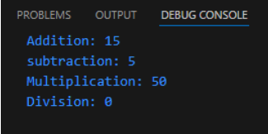

**//Task 4**

let firstName = "leo";

let lastName = "Rahman";

let fullName = firstName + " " + lastName;

console.log("Concatenation Example:");

console.log("First Name:", firstName);

console.log("Last Name:", lastName);

console.log("Full Name:", fullName);

**OUTPUT**

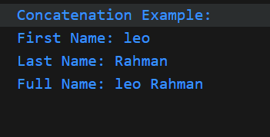

**//Task 5:**

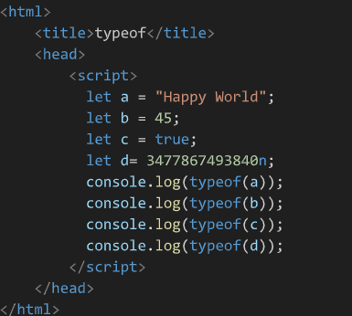

Output

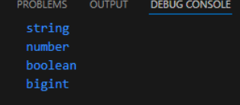

**//task 6**

/*

  This is a multi-line comment.

console.log("First Name:", firstName);

console.log("Last Name:", lastName);

console.log("Full Name:", fullName);

*/

// This is a single-line comment.

**//task 7**

 let x = 10;

let y = 20

x = x + y

console.log(x);

**OUTPUT**

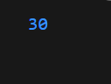

**//task 8**

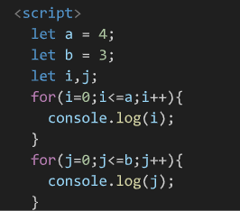

Output

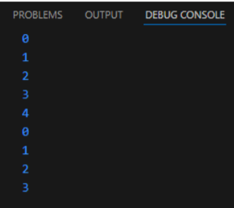

**//task 9**

let a = 5, b = 10, c = 15;

**//task 10**

<!DOCTYPE html>

<html lang="en">

<head>

  <meta charset="UTF-8">

  <title>Script at the Top</title>

  <script>

    console.log('This script is loaded before the HTML content.');

  </script>

</head>

<body>

  <h1>Hello, World!</h1>

</body>

</html>

<!DOCTYPE html>

<html lang="en">

<head>

  <meta charset="UTF-8">

  <title>Script at the Bottom</title>

</head>

<body>

  <h1>Hello, World!</h1>

  <script>

    console.log('This script is loaded after the HTML content.');

  </script>

</body>

</html>

Output

SAME OUTPUT

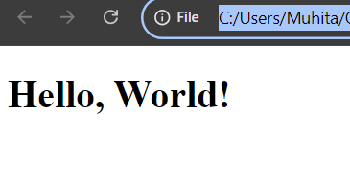

**//task 11**

x = 10;

console.log(x);

output

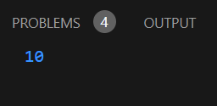

**//task 12**

<!DOCTYPE html>

<html lang="en">

<head>

  <meta charset="UTF-8">

  <title>Script at the Top</title>

  <script>

  'use strict';

x = 10;

console.log(x);

  </script>

</head>

<body></body></html>

Output

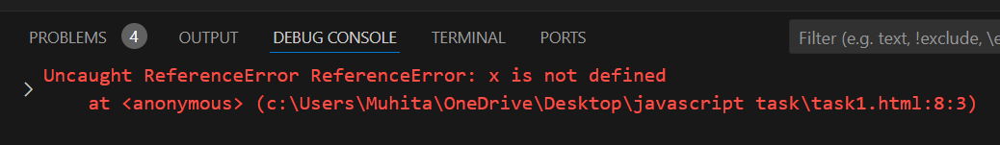

**//task 13**

<!DOCTYPE html>

<html lang="en">

<head>

  <meta charset="UTF-8">

  <title>Script at the Top</title>

  <script>

  'use strict';

let y = 20;

delete y;

console.log(y);

  </script>

</head>

<body>

</body>

</html>

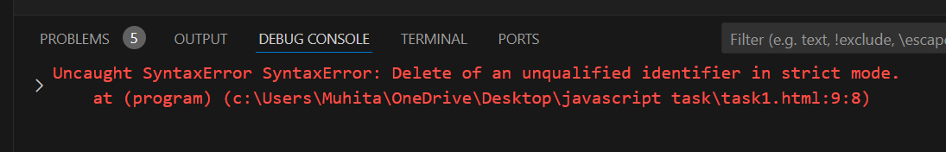

**//TASK 14**

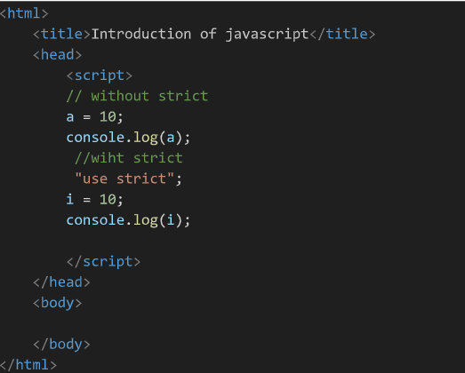

OUTPUT

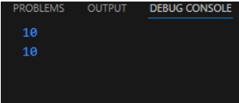

**//task 15**

<!DOCTYPE html>

<html lang="en">

<head>

  <meta charset="UTF-8">

  <title>Script at the Top</title>

  <script>

  'use strict';

let default = 10;

console.log(default);

  </script>

</head>

<body>

</body>

</html>

output

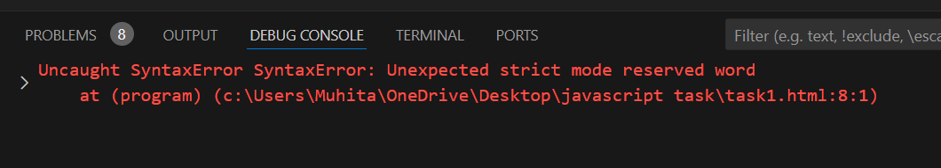

**//task 16**

let a = 10;

const b = 20;

var c = 30;

//task 17

const x = 10;

x = 20;

console.log(x);

**output**

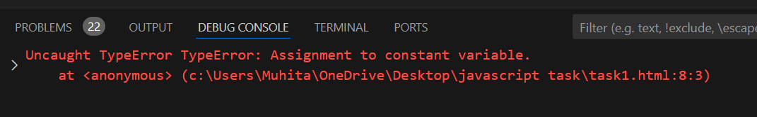

**//task 18**

let y;

console.log(y);

output

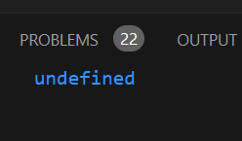

**//task 19**

let num = 5;

let str = "Hello, world!";

let bool = true;

console.log(typeof num);

console.log(typeof str);

console.log(typeof bool);

**output**

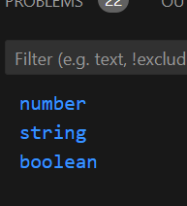

**//task 20**

let oldName = "John";

let newName = oldName;

console.log(newName); console.log(oldName);

**output**

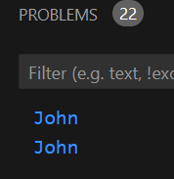

**//task 21**

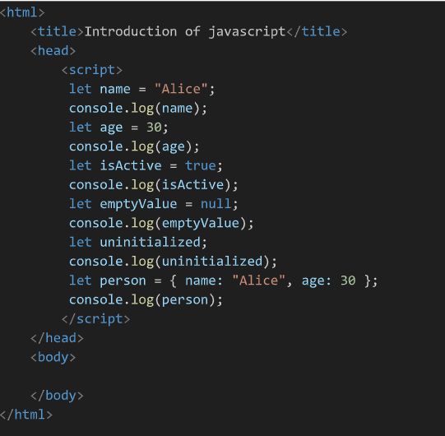

**Output**

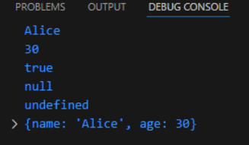

**//task 22**

console.log(typeof str);  // Output: "string"

console.log(typeof num);

console.log(typeof bool);

console.log(typeof n);

console.log(typeof undef);

console.log(typeof obj);

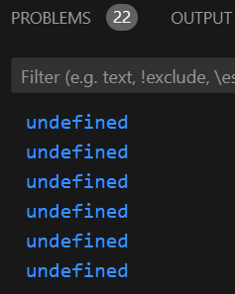

**//task 23**

let sym = Symbol("description");

console.log(typeof sym);

**output:**

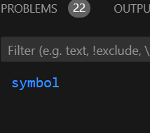

**//task 24**

let nullVar = null;

console.log(typeof nullVar);

**output**

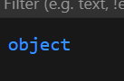

**//task 25**

// Using var:

function testVar() {

  if (true) {

    var x = 10;  // var is function-scoped

  }

  console.log(x);  // Output: 10

}

testVar();

// Using let:

function testLet() {

  if (true) {

    let y = 20;  // let is block-scoped

  }

  console.log(y);  // Error: y is not defined

}

testLet();

output:

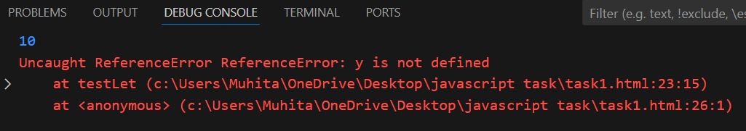

//task 26

 let str = "123";

let num = str * 1;

console.log(num);

output

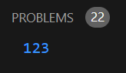

let str = "123";

let num = Number(str);

console.log(num);

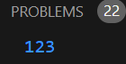

**//task 27**

let bool = true;

let str = String(bool);

console.log(str);

console.log(typeof str);

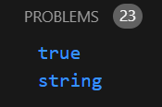

//Convert into boolean

let str = "false";

let bool = (str === "true");

console.log(bool);

console.log(typeof bool);

output

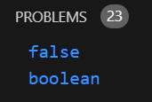

//task 28

let a = 10;

let b = 5;

console.log(a + b);

console.log(a - b);

console.log(a * b);

console.log(a / b);

console.log(a % b);

Output:

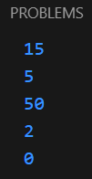

**//task 29**

let num = 5;

num++;

console.log(num);

num--;

console.log(num);

++num;

console.log(num);

--num;

console.log(num);

Output:

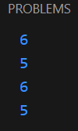

**//task 30**

let result = 10 + 5 * 2 - 3 / 3;

console.log(result);

output:

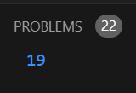

**//task 31**

let num1 = 10;

let num2 = 20;

console.log(num1 > num2);

console.log(num1 < num2);

console.log(num1 >= num2);

console.log(num1 <= num2);

output:

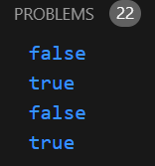

**//task 32**

let num = 10;

let str = "10";

console.log(num == str

console.log(num === str);

output:

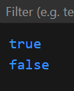

**//task 33**

let str1 = "apple";

let str2 = "banana";

console.log(str1 < str2

console.log(str1 > str2);

output:

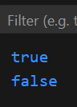

**//task 34**

let val1 = 5;

let val2 = "5";

console.log(val1 != val2);

console.log(val1 !== val2);

output:

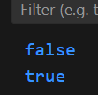

**//task 35**

console.log(null == undefined);

console.log(null === undefined);

output:



**//task 36**

let number = 15;

if (number % 2 === 0) {

console.log("Even");

} else {

console.log("Odd");

}

Output:

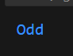

**//task 37**

let num = -5;

if (num > 0) {

console.log("Positive");

} else if (num < 0) {

console.log("Negative");

} else {

console.log("Zero");

}

Output:

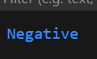

**//task 38**

let age = 18;

let message = (age >= 18) ? "Adult" : "Minor";

console.log(message);

output:

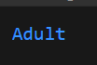

**//task 39**

let username = "";

let isValid = (username) ? "Valid" : "Invalid";

console.log(isValid);

output:

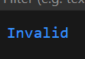

**//task 40**

let score = 85;

let grade = (score >= 90) ? "A" : (score >= 75) ? "B" : "C";

console.log(grade);

output:



**//task 41**

 let a = true;

  let b = false;

        console.log(a && b);

        console.log(a || b);   console.log(!a);

Output:

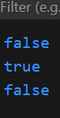

**//task 42**

let num = 15;

let isInRange = (num > 10 && num < 20);

console.log(isInRange);

**output:**

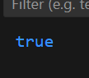

**//task 43**

let isAvailable = true;

console.log(!isAvailable);

**output**

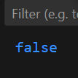

**//task 44**

let x = 5;

console.log(x > 0 || x++);

console.log(x);

console.log(x < 0 && x++);

console.log(x);

**output:**

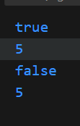

**//task 45**

let value1 = "Hello";

let value2 = "";

console.log(value1 || value2);

console.log(value1 && value2);

**Output:**

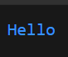

**//task 46**

function sum(a, b) {

return a + b;

}

console.log(sum(5, 10));

**Output:**



**//task 47**

function calculateArea(length, width) {

return length * width;

}

console.log(calculateArea(5, 3));

**Output:**



**//task 48**

function greet() {

console.log("Hello, World!");

}

greet();

**output:**

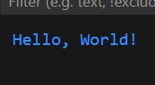

**//task 49**

function doNothing() {

// no return statement

}

let result = doNothing();

console.log(result);

**output:**

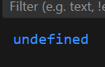

**//task 50**

function greetUser(name = "Guest") {

return `Hello, ${name}!`;

}

console.log(greetUser());

console.log(greetUser("Muhita"));

**output:**

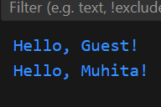

**//task 51**

const greet = (name) => `Hello, ${name}!`;

console.log(greet("peter"));

console.log(greet("John"));

console.log(greet("Alice"));

**output:**

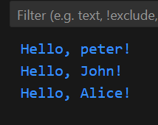

**//task 52**

const add = (a, b) => a + b;

console.log(add(5, 3));

console.log(add(10, 20));

console.log(add(-2, 4));

**output:**

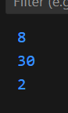

**//task 53**

const isEven = (num) => num % 2 === 0;

console.log(isEven(4));

console.log(isEven(7));

console.log(isEven(0));

**output:**

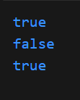

**//task 54**

const maxValue = (a, b) => {

return a > b ? a : b;

};

console.log(maxValue(10, 20));

console.log(maxValue(30, 15));

console.log(maxValue(5, 5));

**output:**

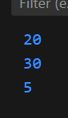

**//task 55**

 <script>const myObject = {

        value: 10,

        multiplyTraditional: function (num) {

          return this.value * num;

        },

        multiplyArrow: (num) => {

          return this?.value * num;

        }

      };

      console.log(myObject.multiplyTraditional(2));

      console.log(myObject.multiplyArrow(2));

    </script>

**Output:**

